TECbikepartsUSA.com

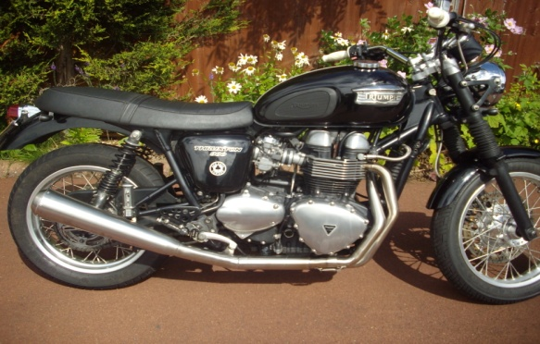
STAINLESS 2 into1 EXHAUST SYSTEM
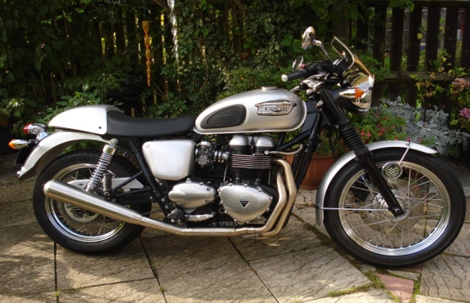
See how to install it and hear it running on youtube
http://www.youtube.com/watch?v=uuHGoRbPSb0
Go to our web site www.tecbikepartsusa.com for a simple, clickable link to view this video in the 2-1 Exhaust details

Thank you for purchasing our product. Owners with at least a moderate level of mechanical ability should find installation straight forward. Otherwise, we recommend the work be performed by a qualified technician. We have tried to make these instructions as clear as possible. Further guidance may be found in the video. However, if you still have problems with installation, please contact us at: customerservice@tecbikepartsusa.com

This system is suitable for both EFI and Carburetor models: on Carburetor models you will need to fit the blanking plugs and copper washers supplied with the kit to the front header pipes.

PLEASE READ ALL THESE INSTRUCTIONS THOROUGHLY BEFORE ATTEMPTING TO INSTALL THE EXHAUST

Health & Safety:
- Only to be installed or thoroughly checked by a mechanic or other competent person before use.
- Please ensure bike is properly supported before installation process, to avoid risk of injury from the motorcycle falling.
- If the motorcycle has been running, make sure all parts have cooled before carrying out any work due to risk of burns.

1. Disconnect the battery and then remove the original exhaust silencers and front header pipes.

EFI bikes only
* Remove sensors from the front header pipes before removing them from bike.

! IMPORTANT !
On EFI bikes, sensors and connecting leads MUST be marked 'LEFT' and 'RIGHT' and refitted to the correct side exhaust otherwise EFI system will not work correctly.

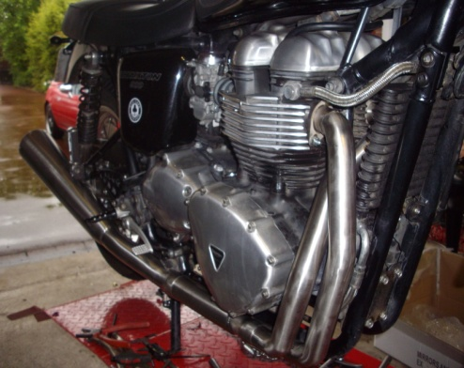
2. Remove mountings from the original exhaust for re-use on new exhaust. Remove exhaust seals from cylinder head and discard.

3. Fit new exhaust seals supplied to cylinder head and fit the header pipes; LEFT HAND pipe first. Only loosely fit the pipes at this stage.

NOTE: It is important to keep the new exhaust as clean as possible during the installation process to avoid staining when it gets hot.

EFI bikes only

You will need to fit the original sensors to the new header pipes at this stage. The wiring will need re-routing, this may require the horn and the oil cooler mounts to be loosened or removed. The cable should then be routed and clipped up with the tie provided, making sure it is not stretched or running too close to HOT parts.

NOTE: DO NOT USE EXHAUST PASTE in the installation of the exhaust system. Its only approved use is for securing the exhaust seals in the cylinder head if desired.

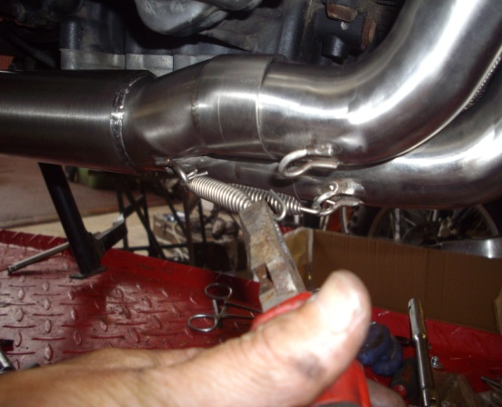
4. Offer up the intermediate pipe to the front pipes and push them fully home. This is quite difficult for one person and may be easier with assistance. Once fitted, attach the retaining springs between intermediate and front pipes. (Wear eye protection when fitting.)

5. Fit the rubber bushes from original exhaust to the silencer. Fit the silencer to the intermediate pipe, making certain it is all the way in. Fit the footrest mounting loosely and then fit the centre frame mounting. DO NOT TIGHTEN AT THIS STAGE. Note: on Bonneville models you will need to remove the right front footpeg assembly and sprocket cover to gain access to the center frame/exhaust mounting.

EFI bikes only

Reconnect the sensor wires making sure the RIGHT HAND sensor connects to the connector marked with RED tape on the harness. If oil cooler has been loosened, re-tighten the oil cooler mounting bolts to 9 Nm or 7 lb/ft

6. Tighten the rear footpeg mount to 24 Mn or 19 lb/ft and then tighten the center frame/exhaust mount to 21 NM or 16 lb/ft.

7. On some bikes, it may be necessary to reposition the oil cooler pipe centrally between the front pipe and frame. Do this by loosening the banjo fitting and then moving the pipe before re-tightening.

8. Check that the front header pipes are fully seated in the intermediate pipe by tapping then home with a rubber mallet to avoid marking or damaging the pipes. Carefully tighten the exhaust/cylinder head clamp nuts evenly, making sure that the seals are correctly seated in the cylinder head. Tighten to 18 Nm or 14 lb/ft.
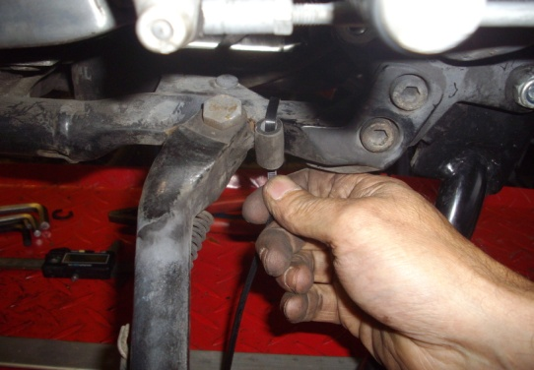
9. Carefully tighten the exhaust/cylinder head clamp nuts evenly, making sure the seals are correctly seated in the cylinder head. Tighten to 18 Nm or 14 lb/ft.

NOTE: At this point it is important to thoroughly clean all of the new exhaust with brake cleaner or a similar product to remove grease and fingerprints otherwise permanent staining may occur when the exhaust heats up

10. Pass a cable tie through the short piece of rubber hose provided, then pass the tie around the frame, close to the side stand pivot bolt. This will act as a stop for the stand to stop it retracting too far and to prevent it rattling.

11. Reconnect battery and start the bike. A small amount of leakage will occur at the joints on the pipes but this is normal on this type of system as it relies on heat expansion to seal the joints.

12. Do not run the bike without the baffle in place with the standard fuel system as engine damage may occur due to a weak mixture. If you want to run without the baffle we recommend larger jets on Carburettor models. On EFI models we also recommend that the fuel program is updated to Arrow system specification by a Triumph dealer or specialist tuner to get the best from the system, even with the baffle in place.

13. After road test, allow the system to cool, then re-check front pipes are seated correctly and re-tighten all bolts to the correct torque.

NOTE: Exhaust will discolour somewhat in use; this is normal and a feature of all stainless exhaust systems.

NOTE: CENTER STANDS: It will be necessary to install a bracket for the bump stop rubber which will have been included if you have specified that you do have a center stand fitted at the time of ordering.

